One-page design document

*DO NO REQUEST ACCESS. Go to FILE > Make Copy*

## Game Identity / Mantra:

List your single sentence description of the game that you will use to guide design decisions. (Example: *Stylized action platformer about a meatball fighting the dinner table.)*

*A single player strategy game about a tank destroying other tanks*

## Design Pillars:

List up to 3 words/phrases that convey the feeling or emotion you want the player to experience. (Example: *Fast. Action-packed. Mayhem.*)

Strategic, Action, Casual

## Genre/Story/Mechanics Summary:

List what the game is from a gameplay and/or story perspective. (Example: *This game uses a unique swinging rope mechanic to tell a story about what it means to be a meatball...*)

This game uses a moving and shooting mechanic to destroy enemy tanks and be the last one standing

## Features:

List the cool features or unique elements that you want to include in your game.

Shooting, moving, powerups, tank types, ricochet

## Interface:

List the player input method, the controls, and how the player interacts with your game.

Turn with A and D, and move forward/backward with W and S. Aim the turret with the mouse and click to shoot

## Art Style:

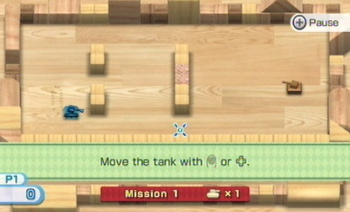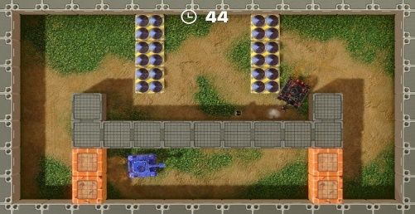Include references to lots of images and games that have a similar aesthetic to what you're trying to achieve.

3D top down viewing angle

Music/Sound:

Include links to music and sound design similar to What you're trying to achieve. You can also list the emotional responses that the sound should invoke in the player.

Tank noise (motor) that gets louder/softer depending on the distance from another tank.

Music that changes volume depending on how close you are to a tank.

## Development Roadmap / Launch Criteria:

**Platform:** Windows OS **Audience:** Any age, strategic thinkers

|  |  |
| --- | --- |
| **Milestone 1:** Mechanics complete - 0/0/00  **Milestone 2:** Boss fights complete - 0/0/00  **Milestone 3:** Levels complete - 0/0/00 | **Milestone 4:** Polish complete - 0/0/00  ---------------------------  **Launch Day:** 0/0/00 |

Tanks Basic Gameplay Presentation

The objective is to destroy all enemy tanks before they hit you.

The weapons you have to attack with are:

-Normal shot (takes one ammunition that bounces once)

-Charge shot (takes two ammunition that is increased speed and bounces three times *takes three seconds to charge)

-Land mine (can be tossed over walls and destroys enemy tank with direct contact)

//Possibly you can destroy yourself with your own bullets

You have limited ammunition and limited amount of mines

You have three lives, if you lose all of them you have to go back to stage one

Control tank movement with WASD keys, shoot tank with left-click

Shoot mines with spacebar

Control where the tank is going to shoot with mouse

Tank movement and rotation are separate

Walls prevent you from going in that area, and bullets bounce off walls

Small UI, interact with game to start and pause, etc.